Central Escarpment Cuboree: Offer of Service Registration Package
June 12th to 14th, 2020
Blue Heron/BSSR WEST 14014 6th Line Nassagaweya
Thank-you for choosing CECuboree! This package contains all the information for Offers of Service to prepare for our camp. Your volunteerism is most welcomed and will help make this an amazing camp experience. Please review all the package contents carefully to ensure you have the best possible experience, and if you have any questions do not hesitate to contact the camp staff at contact@cecuboree.scouter.ca
Sincerely,
Your CECuboree Team

Central Escarpment Cuboree: Offers of Service Welcome Package
Price:
$15 with camp provided meal plan
$5 with if you bring your own food/arrange to eat with an attending Cub Pack
Pricing includes crest, food if you choose meal plan, and contribution to kybo/site services rental.
Participation confirmation is required via submission of our on-line registration form by Friday May 29th, 2020 to allow us time to assign OOS to activities.
Medical Forms:
Scouts Canada Medical and Emergency Contact Forms for all participating Offers of Service are required. Please ensure information is up to date. To get these forms, run a member details report from your section myscouts.ca account under the Quick Reports tab shown below. Alternatively, if you are not able to obtain your scouts.ca report you may fill in the physical fitness form for non-members.
Quick Report to get member details including medical and emergency contact information:
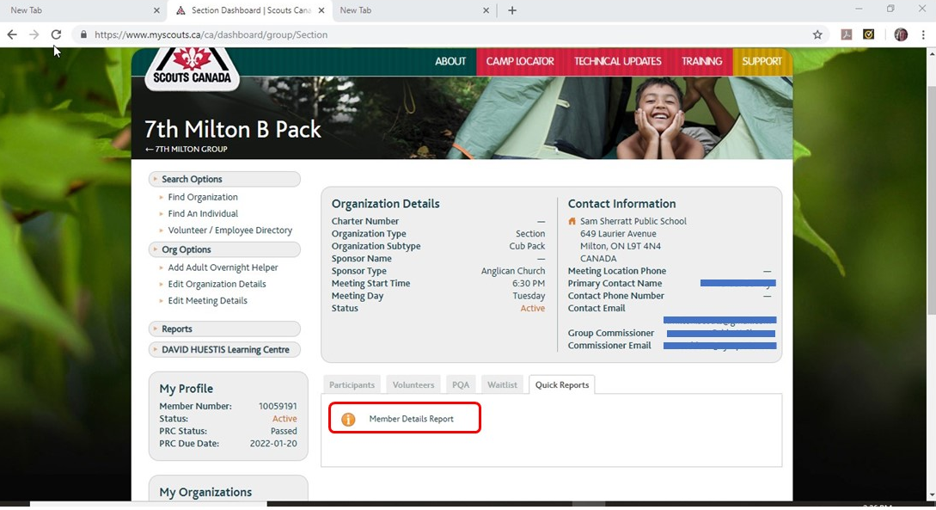
Physical Fitness Form Link for Non-Members:
http://www.scouts.ca/wp-content/uploads/forms/Physical-Fitness-Form_Non-Members.pdf
ONE HARD COPY OF THE EMERGENCY CONTACT AND MEDICAL FORMS OR PHYSICAL FITNESS FORMS IS REQUIRED TO BE PROVIDED WHEN YOU REGISTER ON ARRIVAL for use by Camp Medical Staff for treatments as required. Please ensure you have a copy of your emergency contact information at your site as well.
Code of Conduct
All youth and adult OOS are required to read and provide us with a signed copy of the applicable code of conduct on arrival. It is found at this link: http://www.scouts.ca/wp-content/uploads/safety/Code-of-Conduct.pdf
Arrival and Registration (Full Weekend OOS):
Upon arrival, please register at the Camp HQ before setting up your camp. This is where you will receive your camp crest and camp necker. Payment is required upon arrival, if still owing. Arrival time is between 5 and 7 PM on Friday June 12th.
Departure (Full Weekend OOS):
Upon departure, please take all your garbage with you and clean up your site. You will need to get your site checked by a member of the Security Team before you leave. Departure time is before 12:00 pm on June 14.
Arrivals and Registration (Saturday Only OOS):
Please register at the Camp HQ when you arrive. This is where you will receive your camp necker, and wristband. Payment is required upon arrival, if still owing. Arrival time is no later than 8:00 am on Saturday June 13th.
Departures (Saturday Only OOS):
Please sign out at Security Head Quarters before leaving. All Day Offers of Service’s must be departed from the camp before 10:00 pm on June 13th.
Camping:
All Venturer and Rover Offers of Service will camp in the OOS Subcamp unless specific request made otherwise. You may choose your own site within the designated area so first come first serve. Scout OOS youth are welcome but should camp with their attending Cub packs unless Troop minimum scouter ratios can be maintained in the OOS sub-camp.
Food/Cooking:
You have the option of bringing your own food choosing the Camp OOS Meal Plan. Any OOS participants choosing to cooking their own food are to dispose of all their garbage properly. Cooking must not be done near tents to reduce the fire hazard. Propane or white gas only for cooking fuel. Each OOS must bring mess kit. The camp offers a meal plan, where food is provided for you.
Garbage:
The camp does not have garbage disposal facilities. Each OOS and Group is responsible for managing their own garbage collection. All garbage must be removed from the camp by the producer of said garbage.
Washrooms:
Portable toilets and outhouses are located throughout the camp, and camp outhouses will be available in the OOS camping area.
Camp Neckers:
OOS Camp Necker must be worn at all times. If you lose your necker, please go to Security Head Quarters ASAP. Anyone without their neckers will be asked to put it on. Neckers will be traded in at the end of camp for a camp crest. You may choose to purchase your Camp Necker for $5.00.
Activities for OOS:
There is an opportunity for OOS to take in a movie, and do their own exploring and activities after the scheduled activities are done for the day.
Hydration:
Please keep hydrated as much as possible. Drink lots of water and Security Personnel will be around with water bottles if you need more during activity times.
Charging Devices:
There will be no outlets or sources available for charging personal electronic devices.
Coffee and Tea:
Coffee and tea will be available to all Offers of Service and Scouters at Swallow’s Nest. Please bring your own mug.
Offer Of Service Subcamp:
Venturer and Rover Offer Of Service participants will have their own subcamp separate from the cub youth subcamps. No cub youth are to be allowed into OOS Subcamp. Please respect everyone around you and keep noise levels to a minimal during quiet hours. Also, remember there is youth around who look up to you as a role model. Scouts Canada’s B.P.&P. will be enforced. Scout OOS may have the option of camping in the OOS area but only if Troop youth/scouter ratios are met.
Lost and Found:
If there are any items left behind at your activity, please give them to a Security Personnel or please bring them to Security Head Quarters when you have a chance. If you lose something, please go to Security Head Quarters to see if it has been returned. At closing, all items in the Lost and Found will be presented and those items which are not claimed, will be either donated or disposed of.
OOS Meeting
There will be an OOS meeting at approximately 8 PM Friday June 12th. Final time will be on your schedule that you will receive at registration.
Questions:
If you have any questions, please contact Brad Farmer at Camp Head Quarters or call/text 519.212.7254.
Camp Activity Assignment:
There are many activities both active and administrative which need people to run them. Please select the top 3 activities you would like to run when you register. We cannot guarantee you will get the activity you would like, but each activity is fun for all to participate in and run. Your activity assignment will be provided on arrival unless previously arranged with our OOS chief.
If there is an activity you think would be a fantastic addition, we welcome ideas. Please let us know at contact@cecuboree.scouter.ca by Friday May 29th,2019!
Activity Expectations:
Thank you for taking your time to help run an activity for the youth.
The Offer of Service participants running the activities are responsible for setting up the activity they are assigned Friday evening or Saturday morning by 9 AM and cleaning up Saturday evening after the end of the activity time. Instructions and supplies for each activity will be provided at the camp Friday evening. There will be an hour break, between 12:00 pm and 1:00 pm for lunch. Please be back to your activity about 12:50 pm as groups will begin to circulate again.
Sample OOS Menu
- Friday Meeting Snack – Tea, Hot Chocolate, sweets & snacks
- Saturday Breakfast – Sausage or Back Bacon on a Bun, accompaniments, Fruit, Coffee &/or Tea
- Saturday Lunch – Deli Sandwiches, Vegetables and Dip, (Soup if cold weather), Dessert, Drinks
- Saturday Dinner – BBQ Pork chops, mashed potatoes, salad, Dessert, Drinks
- Saturday Evening Snack - Tea, Hot Chocolate, snacks
- Sunday Breakfast – Muffins & Bagels, accompaniments, Fruit, Coffee &/or Tea
- Water and snacks will be provided throughout the day Saturday while you run your activity
Please advise of any special dietary requirements or allergies when you register, or email to the OOS Chief (OOSChief@cecuboree.scouter.ca).

